Worksheet — Circular Motion Simulation
Use with Simulation - Circular motion.html · circular motion (Block 5): rotating chair, satellite, car on a bend, playground carousel
Biljana Taneska · Physics teacher · btaneska@vis.ac.at

Name: ______________________________ Class: ________ Date: ______________
How to use this worksheet  Scan the QR code or open school.taneski.com/physics/dp/16-circular-motion in a browser (offline: Simulation - Circular motion.html). Choose an example at the top: 🪑 rotating chair · 🛰️ satellite · 🚗 car on a bend · 🎠 carousel. Set values with ▼ ▲, or type a value in the box.  Part 1 before the lab (≈ 15 min) · Part 2 during the lab (≈ 20 min) · Part 3 homework (≈ 30 min). The Tasks tab has the same three parts.  Use g = 9.81 N kg⁻¹, G = 6.67 × 10⁻¹¹ N m² kg⁻², Earth: M = 5.97 × 10²⁴ kg, R = 6.37 × 10⁶ m. |   Scan to open

Part 1 — Pre-lab: predict, then test
Question | My prediction (before) | What the simulation showed | Physics explanation
1. 🚗 A car goes round a bend at constant speed. Which way does its acceleration point?
2. Which real force pushes the car towards the centre on a flat road?
3. Same bend, twice the speed. The friction needed is × ____ ?
4. 🎠 Child C lets go of the handle. Which path does C take?
5. 🪑 Same ω: arms open (0.75 m) instead of closed (0.20 m). The arm's pull is × ____ ?
6. 🛰️ A satellite moves to a higher circular orbit. Faster or slower?

7. 🚗 Draw the free-body diagram of a 1200 kg car on a flat bend of radius 50 m at 15 m s⁻¹, seen from behind (the centre of the bend is on the left). Then calculate the friction force it needs. Check with the FBD in the simulation.
Free-body diagram and working

Part 2 — During the lab
A · Phone on a spinning chair (phyphox). Simulation: 🪑 chair, Motor mode, mass in each hand m = 0.20 kg (the phone), arms open r = 0.50 m. Type each period T in the box, then read the acceleration of the hand (arms open).
T / s | ω = 2π/T / rad s⁻¹ | ω² / rad² s⁻² | simulation a / m s⁻² | class phone a / m s⁻²
1.0
1.5
2.0
2.5
3.0

8. Plot a against ω² and draw the best-fit line. Gradient = __________ . What does the gradient represent?
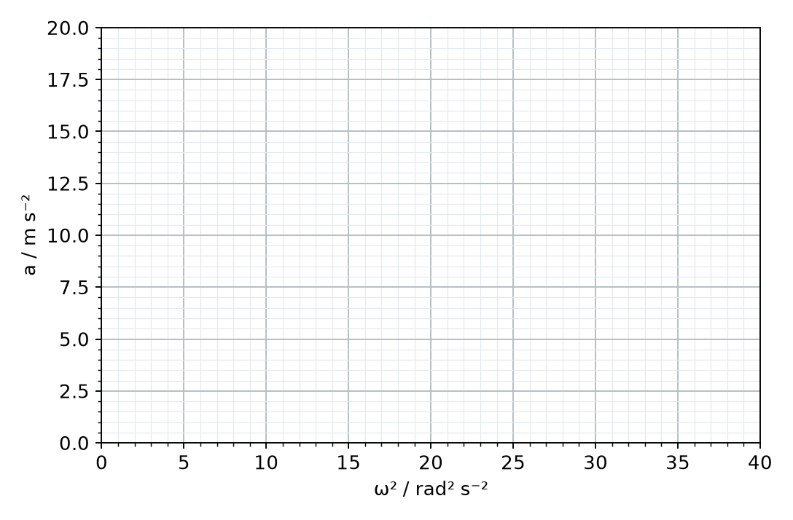
9. Compare your gradient with the distance of the class phone from the axis of the chair. Give one reason why the phone's graph is not a perfect straight line.
______________________________________________________________________________________
______________________________________________________________________________________
______________________________________________________________________________________
B · Playground carousel. Simulation: 🎠 carousel, T = 4.0 s, three children of 30 kg at 0.60 m, 1.20 m and 1.80 m. Strongest grip 150 N.
child | r / m | v = ωr / m s⁻¹ | grip needed F = mω²r / N | holds on?
A | 0.60
B | 1.20
C | 1.80

10. Calculate the shortest period T at which child C can still hold on (grip 150 N). Then lower T in the simulation in steps of 0.1 s and find when C lets go. Describe C's path after letting go.
Working

C · Extension (beyond SL): the rotating-chair demo. Simulation: Free spin ★, T = 3.0 s with arms open, 1.0 kg in each hand. Press ▶ Start, then 🤏 Pull arms in.
11. Read ω and T before and after pulling the arms in, and the kinetic energy. Explain why ω increases, and where the extra kinetic energy comes from.
______________________________________________________________________________________
______________________________________________________________________________________
______________________________________________________________________________________
______________________________________________________________________________________

Part 3 — Homework
12. 🚗 Flat road, 1200 kg car, r = 50 m, dry asphalt. Record the friction needed at each speed, then plot F_{f} against v².
v / m s⁻¹ | 5 | 10 | 15 | 20 | 25
v² / m² s⁻²
F_{f} / N

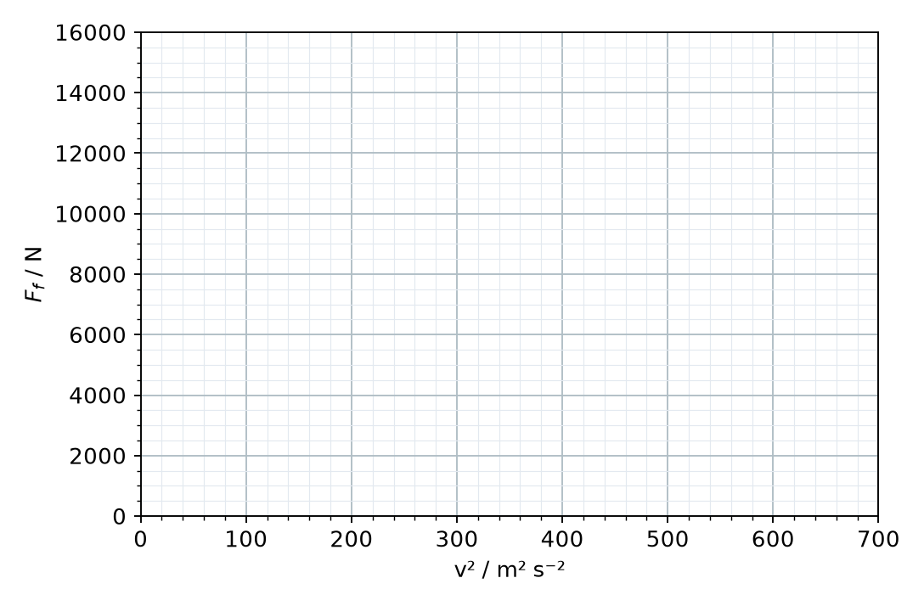
Gradient = __________ . Show that the gradient equals m/r.
13. On wet asphalt (μ_{s} = 0.50), calculate the maximum speed on the 50 m bend. Would a 2400 kg van have a different maximum speed? Explain.
Working

14. 🛰️ The ISS orbits 410 km above the Earth's surface. Calculate its orbital speed and its period (in minutes).
Working

15. A geostationary satellite has a period of 24 h. Calculate the radius of its orbit and its height above the surface.
Working

16. Choose each orbit from the Orbit list and read the period. Complete the table and plot T² against r³ (or use the Data tab). Use the gradient to find the mass of the Earth.
orbit | h / km | r / m | T / s | r³ / m³ | T² / s²
ISS | 410
Hubble | 540
GPS | 20 200
Geostationary | 35 857

Gradient and mass of the Earth

17. 🪑 Motor-driven chair, T = 1.5 s, arms open (0.75 m), 1.0 kg in each hand. Draw the FBD of one mass and calculate the inward force the arm exerts on it, and the total force of the hand.
Free-body diagram and working

18. Your friend says: "On the carousel a centrifugal force throws you outwards." Use the free-body diagrams in the simulation to explain what really happens.
______________________________________________________________________________________
______________________________________________________________________________________
______________________________________________________________________________________

